**CMPS 5153: Advanced Software Engineering**

Department of Computer Science

Midwestern State University

**Church Financial Record Keeping**

Version -2

User Interface Designs

**Advanced Software Engineering**

Team #5 Fixit

Saboor Siddiqie, Sapna Patil,

Kranthi Paladugu, Mrudula Kosaraju.

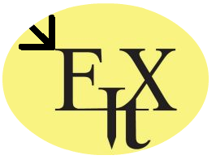

October 8 , 2015